|  |  |  |  |  |  |  |  |
| --- | --- | --- | --- | --- | --- | --- | --- |
|  | |  | |  | |  | |
|  | |  | |  | |  | |
|  |  | |  | |  | |

**Inception Report**

**Child Helpline System Upgrade And Mental Health Chatbot Api Development For Kenya & Tanzania**

**14 June, 2021**

 

Contents

Acronyms 2

Acknowledgments 3

Executive Summary 4

Introduction 4

Proposed Solution. 4

Scope 5

Requirements Gathering – Kenya 6

List of Participants 6

Summary of Key Findings 6

Requirements – Kenya 6

Mental Health CHATBOT Integration. 8

Chatbot configuration. 9

Other Findings and Recommendations 12

Summary Infrastructure Requirements 13

Requirements Gathering – Tanzania 14

List of Participants 14

Summary of Key Findings 14

Summary Requirements - Tanzania 15

Other Findings and Recommendations 17

Infrastructure 17

Hardware Findings 17

Proposed Infrastructure - All Countries 18

Operations and Roles 19

Partners(UNICEF, Government etc ) 19

Administrator 19

Counsellor 19

Supervisor 19

Case Escalation Process 20

Reporting Module 20

Pivot Reports 20

Comprehensive Reports 20

Appendix 1: Kenya Infrastructure Upgrade 22

# Acronyms

GBV Gender Based Violence

VAC Violence Against Children

FRD Functional Requirements Document

ACHT Average Call Handling Time

TAT Turn Around Time

QC Quality Control

MNO’s Mobile Network Operators

LAN Local Area Network

UPS Uninterrupted Power Supply

NITA National Information Technology Authority

BITZ ITC Bitz IT Consulting Ltd

# Acknowledgments

The BITZ ITC team would like to express our gratitude to all who took the time to speak to us during this exercise

We were able to meet and share experiences with the helpline teams in Kenya & Tanzania.

Because of this support we believe that we can now go ahead and customize the system to fit the operations of indivdual Country Helplines. At the same time, we accept responsibilities for any errors, omissions or misunderstandings in this report.

# Executive Summary

## Introduction

OPENCHS is a case management system with a call tracker for Child Helplines using the global child helpline 116. The system is currently in use in four countries namely ( Kenya, Tanzania, Uganda and now Lesotho). This documents indicates our understanding of the individual OpenCHS country needs and those of 3rd Party provider for the Mental Health CHATBOT This documents is also used as the initial guideline for our Engineers in understanding the initial requirements. The teams have commenced with the customization that will lead towards the deployment and eventual upgrade of OPENCHS for Kenya and Tanzania and development of API endpoints to be consumed by the CHATBOT. BITZ ITC has therefore been requested to develop an API that will enable integration for the Mental Health Chatbot so that all conversations received in the chatbot can also be created in the helpline CRM. Additionally, employees of the helpline can engage with the client upon request and in cases where there are clear indication of RISK as defined in the CHATBOT.

## Proposed Solution.

Bitz ITC has proposed an upgrade of the current solutions in the two countries (Kenya & Tanzania) with the same system being used in Uganda and Lesotho, Because the system is ready for intergration.

The new system is also expected to improve the efficiency of the helpline as it comes ready with reporting, has more features such as WebRTC and is more efficient as compared to the current system. Process optimization has been carried out during development as well as a customizable interface that will allow individual to manage their own categories.

BITZ will develop two API Endpoints to manage the intergration between 3rd Party “WENI” and the individual country helplines. The API will aid in case creation directly from the CHATBOT and whenever live chat interaction is required between the mental health client and the Helpline.

# Scope

The upgrade should put the following into consideration:

1. The system should be able to receive calls for VAC on the toll free number 116 through E1 or SIP trunk channel .
2. System is developed on the Open Source Licence with commonly used languages and necessary documentation provided.
3. Build capacity of the end user teams to be able to make minor adjustments to the system (configurable modules where possible e.g case categories, SIP accounts,) and to manage the system after it has been handed over.
4. Develop a universal documented API to enable integration with other 3rd Party systems.
5. The solution should be able to handle case distribution, routing, escalation based on roles & permissions regarding access for reported VAC cases. This should include follow-ups, case prioritization as well as case closure by providing necessary assistance to the clients who reach out to the Call Center for VAC cases.
6. The system allows for case capture and categorization for reporting and follow up.
7. The solution is expected to be multi-channel Meaning that Cases will be created from multiple: voice, SMS, U-Report, WhatsApp, Web-Online, Tweet-CHAT and CHATBOT with ability to provide distributed and remote terminals.
8. Provide dashboard real time call and case analytics which include sex, age, disability status for Counsellors, Supervisors, Case Managers and Case Workers as well as Performance Management Data based on Key Performance Indicators (KP Is) for individual agents and the helpdesk as a whole for VAC cases.
9. The solution should be able to provide reports based on various metrics and indicators such as (age, sex, disability status,case category) primarily on VAC
10. Design and documentations such as:
    1. End-user training manuals, job aids, reference manuals and quick guide reference cards.
    2. Technical system documentation such as system architecture and technical specifications documentation, system manuals including quick troubleshooting guides and summaries, system administration manuals, guides, configuration, backup and restore procedure manuals.
11. The system should be accessible/friendly to users with disability specifically for vision, hearing and motor skills impairments.
12. Plan and conduct training for: Helpline staff, Helpline Supervisors, case managers (as describe in point 7), local helpline VAC nominated IT STAFF who will act as single point of contact and other relevant staff identified.
13. Provide technical support and ongoing routine maintenance for the Helpline, including regular software updates/upgrades for a period of one year after commissioning of the system.
14. Deploy the enhancements on the hosting platform and secure it with a Secure Sockets Layer (SSL) certificate for added security.
15. Allow remote working by providing agents and/or caseworkers not tied down to the office to handle cases through VPN.
16. Develop a public accessible webpage for the Helpline with information dashboards, information about services of the helpline, documentations among others.
17. Data migration plan and as needed.

# Requirements Gathering – Kenya

## List of Participants

The team comprised of Agents and Helpline superviors , Management Staff and Government representatives.

# Summary of Key Findings

The current system was presented to the users as is currently used in Uganda. The ultimate goal was to record any deviation that could impact the operation of the helpline in Kabete. Our observation initial observation did not indicate any significant changes on the system. The users have requested to minimal removal of some fields deemed as uneccessary for a complete record of the cases.

# Requirements – Kenya

|  |  |  |
| --- | --- | --- |
|  | **Problem** | **Proposed Solution** |
| 1 | Reporter Information Data Capture | Only the following fields will be used when collecting reporter information   * Reporter's Name * Age * DOB * Age Group * Location * Sex * Nearest Landmark * Phone Number * Alternative Contact * Email * Nationality * ID Type * ID Number   Not all the fields are mandatory. This will enable the initial data collection |
| 2 | Client Summary Information | The following fieds will be used on the client information form.   * Reporter's Name * Age * DOB * Age Group * Location * Sex * Nearest Landmark * Phone Number * Alternative Contact * Email * Nationality * Reporter's Relationship with Client * Relationship Comment * Client's Health Status * Client's HIV Status * Clients' Marital Status * Parent/Guardian's Name * Number of Adults in Household * Is the client attending school?{The Address fields are also not needed. } * Yes * No * Unknown * Is the client disabled? * Yes * No * Unknown   All Mandatory Fields will be Marked on the document. |
| 3 | Perpetrator Information | The following fields will be on the perpetrator's formNew Perpetrator   * Perpetrator's Name * Age * DOB * Age Group * Location * Sex * Nearest Landmark * Phone Number * Alternative Contact * Email * Nationality * ID Type * ID Number * Relationship with Client? * Shares Home with Client? * Health Status * Perpetrator's Guardian's Name |
| 4 | Case categories | Case Categories have been lifted from the current system however, its our recommendation that we review what is currently available on the CPIMS system to be used initially. This will greatly improve the quality of data. |
| 5 | Disposal | The teams have suggested that all calls be created as cases only that we create an extra category to indicate Non- Intevention, However as we have enhanced reporting we have proposed to dipose of calls that do not become cases while providing reports for monitoring. |
| 6 | Integration to other systems | We observed that credential for CPIMS are broken and as such the system does not send any information to CPIMS.  It is recommended that this credentials be restored and the information passed to our engineers to configure and push all the Pending cases to CPIMS.  It is also recommended that the CPIMS team provides us with common data like Categories, Age Groups , and Locations. This will improve the Quality of Data sent to CPIMS. |
| 7 | Be able to generate reports based Case status e.g. Pending cases, Closed Cases, Escalated Cases | That the system can generate reports from different dimensions. |
| 8 | Be able to generate reports based Case status e.g. Pending cases, Closed Cases, Escalated Cases | Exists in the current VAC system and will be provided in the upgraded VAC system |
| 12 | Integration to other Sources | The system provides an API endpoints, This upgrade SCOPE is the CHATBOT integration requirement which is listed at the end of this requirement. |
| 13 | The client experience long delays before their call is picked. | The new system has addressed the issue through the integrated web RTC. This means that calls will now be picked directly on the web browser. |
| 16 | The case form popping is not reliable for it at times does not respond |
| 17 | System slows down during the pulling of reports | With the new system the Reporting has been redesigned. |
| 18 | Inability to customize reports | Users will be able to download reports in multiple Dimension. |

# Mental Health CHATBOT Integration.

## Chatbot configuration.

The chatbot requirement have been modified to fit into the following.

|  |  |  |  |  |
| --- | --- | --- | --- | --- |
| Customer Requirement ( BITZ IT Consultants) | Customer Requirement ( BITZ IT Consultants) | Customer Requirements WEI | API Documentation | Comments |
| The Client wants to share some information with the Helplines after interacting with the Chatbot. | provides API Documentation for Case Creation.  {BITZ will provide API endpoint for each site in production} | Weni will consume the API and confirm case creation | <https://documenter.getpostman.com/view/21578213/UzBpLRXa> |  |
| Weni CHATBOT starts a conversation:   * Weni invokes Rapidpro * Rapidpro processes the defined workflow | BITZ will Provide Endpoint/Webhook based on WENI’S Data Definitions.  I.e  The conversation contains a **new conversation_id** (session_id) that uniquely identifies the conversation etc  #User Activity  The BITZ Helpline System ‘hunts’ for an available counselor  The counselor receives a chat notification on the Helpline system  On the counselor ‘reading’ the message, the UI notifies the hunting process that the message is delivered.  If the counselor does not attend to the message within the required timeout, the notification is closed, and ‘hunting’ restarted | WENI Configures RapidPRO workflows, defines and shares the data structure with Bitz team, This will Trigger conversation with the Helplines. |  | The RapidPro workflow calls Webhook, which points to BITZ API Gateway.  Rapidpro should retry incase of network Failures and/or timeout.  BITZ API Gateway should authenticate the message and ensure it is from the correct source and correct format  The Helpline System will notify the API Gateway that the message is delivered  API Gateway will notify Rapidpro of message delivery via an endpoint (to be provided by Weni in the desired format)  Rapidpro will notify Weni of message delivery |
| Conversation acknowledgment | Provides an endpoint for acknowledgement of delivered messages from Weni | Provides an endpoint for acknowledgement of delivered messages from Bitz |  | The acknowledgement endpoints ought to have: conversation ID, from:either helpline system or Weni and the message status |
| Counselor reply:   * The Helpline System send the message to the API Gateway * The Gateway forward the message to Rapidpro |  | WENI Provides API endpoint To receive the message as configured on RapidPRO  #Notes  The message contains the conversation_id and pseudo-name of the current counselor handling the conversion. |  | Rapidpro forward the message to Weni  Weni should send back an Acknowledgement that the message is delivered. |
| Client reply:   * This is similar to ‘start a conversion’ but the conversion_id should already exist * Each message should have a conversation_id, message_id, client’s pseudo-name (since the chats are anonymous) |  |  |  |  |
| Conversation End:   * The conversation can be terminated from either Helpline System or Weni System * Each message should have a conversation_id, message_id, client’s pseudo- |  | WENI should clarify what we do when the actual conversation ends. |  |  |
| Error Handling:   * In the event of a network error, the nodes (ie Weni, RapidPro, API Gateway, Helpline System) should provide retry facility * If the message payload is incorrect (eg missing conversion_id) then a node should respond with a HTTP status code * HTTP status codes should be agreed upon and documented |  |  |  |  |

In Summary

1 .Each Request return immediately with a HTTP status code

2. Each conversation starts with a unique conversation_id

3. Each message should have a unique message_id

4. Each message should have a delivery status

5. A Conversation is closed on sending a termination message

6. For infrastructure requirements each side shall have a public IP and a server hosted on the cloud inorder for us to be able to handle all the Mental Health CHATBOT interactions.

# Other Findings and Recommendations

The helpline requires a revamp of the current infrastructure setup inorder to guarantee security and integrity of the data. We have added an appendix at the end of this document to capture the infrastructure requirements at the helpline.

The helpline has a Libreswan on Centos VPN Available a good Internet Connection that however needs a backup and a Public IP provided by Jamii Telkoms.

**Current Infrastructure**

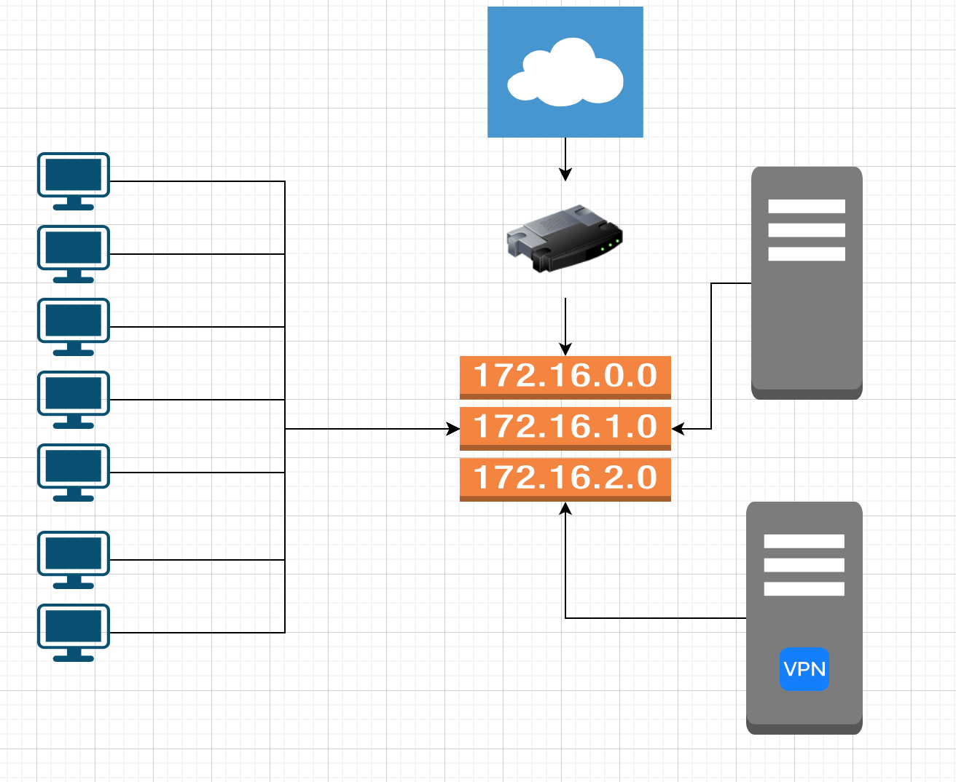

## Summary Infrastructure Requirements

Local Area Network is outdated and needs to be reset to improve Network traffic efficiency. Currently a lot of packets are being lost and this causes low quality communication data which eventually means inefficiency at the Call Center.

116 Toll free line is provided by Jamii Telkom who provide an E1’s Termination and internet to the Helpline. A backup from a different provider is required to cover for downtimes.

The sever room has an inadequate power backup system and whenever there is a power blackout there is an existing Generator which has to be switched on manually.

Hardware as follows:

* 1. HP Server: Model: ProLiant DL380p Gen8 (733646-425) RAM: 16 GB CPU: Intel(R) Xeon(R) CPU E5-2620 v2 @ 2.10GHz Disk: Capacity 1TB, Available: 100GB Approximatley
  2. Cisco Server: Model:  CPU: Intel(R) Xeon(R) CPU E5-2660 0 @ 2.20GHz Processor: 2 Intel(R) Xeon(R) CPU E5-2620 v2 @ 2.10GHz Disk: Capacity 1 TB, Available: 250GB Approximately
  3. There is a HP DL 380 extra Server that remains un used. We have recommended that the server be setup with additional disk space. To accomplish these goals, BITZ IT CONSULTING proposes that the helpline acquires **4 extra hard disks** with the following specifications: HPE SAS 10K SFF SC DS HDD

# Requirements Gathering – Tanzania

## List of Participants

xxxxxxxxxxxxxxxxxxxxxxxxxxxxxxxxxxxxxxxxxxxxxxx

# Summary of Key Findings

xxxxxxxxxxxxxxxxxxxxxxxxxxxxxxxxxxxxxxxxxxxxxxx

# Summary Requirements - Tanzania

|  |  |  |
| --- | --- | --- |
|  | **Problem** | **Proposed Solution** |
| 1 | Reporter Information Data Capture | Only the following fields will be used when collecting reporter information   * Reporter's Name * Age * DOB * Age Group * Location * Sex * Nearest Landmark * Phone Number * Alternative Contact * Email |
| 2 | Client Summary Information | The following fieds will be   * Reporter's Name * Age * DOB * Age Group * Location * Sex * Nearest Landmark * Phone Number * Alternative Contact * Email * Nationality * Reporter's Relationship with Client * Relationship Comment * Client's Health Status * Parent/Guardian's Name * Number of Adults in Household * Is the client attending school?{The Address fields are also not needed. } |
| 3 | Perpetrator Information | The following fields will be on the perpetrator's form. The ones crossed should be removed   * New Perpetrator * Perpetrator's Name * Age * DOB * Age Group * Location * Sex * Nearest Landmark * Phone Number * Alternative Contact * Email * ID Type * ID Number * Relationship with Client? * Shares Home with Client? * Health Status * Perpetrator's Guardian's Name |
| 4 | Case categories | Case Categories have been lifted from the current system however, its our recommendation that we review what is currently available on the CPIMS system to be used initially. This will greatly improve the quality of data. |
| 5 | Disposal | The teams have suggested that all calls be created as cases only that we create an extra category to indicate Non- Intevention, However as we have enhanced reporting we have proposed to dipose of calls that do not become cases while providing reports for monitoring. |
| 6 | Integration to other systems | We observed that credential for CPIMS are broken and as such the system does not send any information to CPIMS.  It is recommended that thiscredentials be restored and the information passed to our engineers to configure and push all the Pending cases to CPIMS.  It is also recommended that the CPIMS team provides us with common data like Categories, Age Groups , and Locations. |
| 7 | Be able to generate reports based Case status e.g. Pending cases, Closed Cases, Escalated Cases | That the syste can generate reports from different dimensions. |
| 8 | Be able to generate reports based Case status e.g. Pending cases, Closed Cases, Escalated Cases | Exists in the current VAC system and will be provided in the upgraded UCHLGBV system |
| 12 | Social media reporting platform not integrated with the CRM | The function will be added in the upgraded system |
| 14 | Referral and feedback mechanism not working | More integrations to government systems envisaged and referrals expected to be more effective in the upgraded system. |
| 15 | The client experience long delays before their call is picked. | The new system has addressed the issue through the integrated web RTC. This means that calls will now be picked directly on the web browser. |
| 16 | The case form popping is not reliable for it at times does not respond |
| 17 | System slows down during the pulling of reports | With the new system the Reporting has been redesigned. |
| 18 | Inability to customize reports | Allow customizing of reports in the upgraded system. |

# Other Findings and Recommendations

## Infrastructure

## Hardware Findings

IT is our understanding that Tanzania will procure new hardware to enable this project. As this is critical to the success of the project. We recommend that this be done ASAP

**Current Infrastructure**

**Server Specification are Identified as seen below**

HP Server:

Model: ProLiant DL380p Gen8 (733646-425)

RAM: 16 GB

1. HPE ProLiant DL20 Gen9 Server

Processor: 2 x Intel Xeon-Gold 6230(2.1GHz/20-core/125W) processor

Memory: 8 GB

Internal Storage: 480GB SATA 6G and 4.2 TB SAS 12G

Power supply: 800W

2 . SIP

3. 30/30  Mbps  ( Dedicated internet)

4. Yes we have a Vpn to Zanzibar for calls only.

5. Will share our public IP .

# Proposed Infrastructure - All Countries

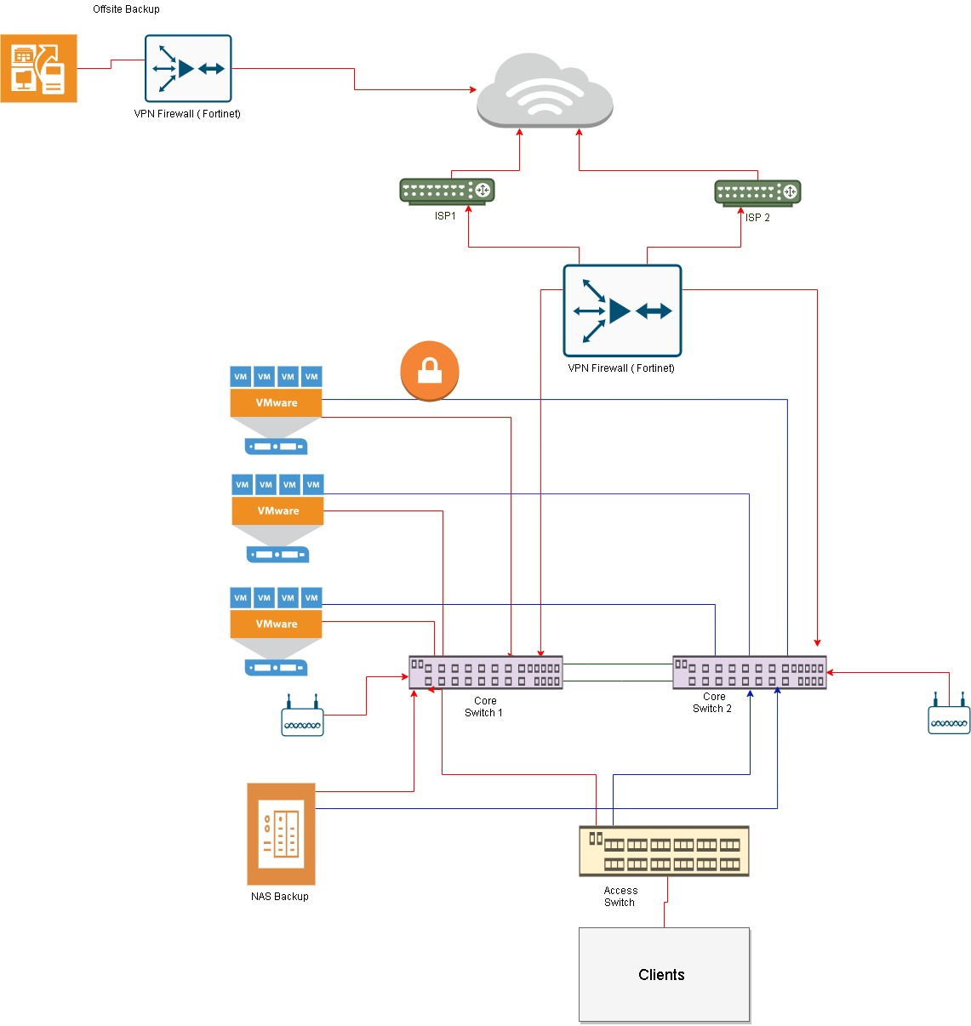

# Operations and Roles

The system shall have the following user levels: administrator, counsellor/agent, and supervisor.

Every user level shall dashboard representative of their account roles and activity including statistics of calls and cases based on parameters such as categories, status, gender, districts, priority and any other applicable field. The dashboards will also have graphical displays line & pie charts, bar graphs, etc.

## Partners(UNICEF, Government etc )

They will be assigned **View** roles so that they can log-in to the system at anytime and view the activities and statistics at the Helpline as may be required. Mostly they will be given access to view reports from the system. This maybe also be achieved through the public portal.

## Administrator

This is a general system administrator responsible for general system configurations, the can view cases, they have minimal or no action. The following are some of the roles by administrators:

* Create and update configurable parameters such as case categories and services offered.
* Manage system users.
* View reports.

## Counsellor

Counsellor handle calls and are mainly based at the call center. They are trained to offer first-line support for both VAC and GBV. Additionally, they:

* create cases from calls
* escalate cases to supervisors
* view their own cases.
* Can search cases from all cases

## Supervisor

A supervisor is the call center manager who is in charge of counsellor/agent work affairs and to ensure they are within the set policies of the helpline. They:

* Can create cases.
* View all cases with an option to update.
* Perform QA on calls.
* Propose system settings and updates to the administrator.

# Case Escalation Process

This is the process in which a case goes through before it’s closed. A case may be closed at the time of creation by the counsellor but sometimes it requires attention from a higher level of the user hierarchy.

A counsellor can escalate a case to a supervisor who in turn can escalate the case to a case manager, the case manager assigns cases to case workers who in most of the time are in the field.

Depending on the case status if the client is a first time Reporter the is allowed to create a new case. In the event that the client contacts already exist in the system the client information will be listed.

# Reporting Module

All activities done on the case management system will result into reports which are used by the supervisors, management and others to analyze the trends and be proactive and take corrective measures to mitigate situations. Both call and case reports shall have list and statistical (pivoted) reports.

There shall be 2 main line of reports.

* Case Management Report – reports regarding case management.
* Call Management Reports – reports pertaining calls.

### Pivot Reports

Pivot report refers to statistical description of the data captured generated by a system user based on select report fields. It presents fields on an X and Y axes form and filtered by date and/or date range.

This gives a permeation & combination of the type of reports required and the different data required. Additional fields can be provided for filtering the reports. This applies to both call and case reports.

The report should be printable or exportable to acceptable formats such as PDF or spreadsheet.

### Comprehensive Reports

These are the main types of reports with listings of records are collected by the system. The module should provide filters for all of these kinds of reports to allow users get what is needed for a particular purpose. The filter may include date created, location, categories, gender, status among others.

These reports include:

* Call Reports
* Case Reports
* Counsellor Reports
* Performance Reports

The comprehensive reports shall have export option to formats such as XLSX, CSV, XLS and PDF either for further analysis or presentation.

# Appendix 1: Kenya Infrastructure Upgrade